Digital Media Kit | 2019

E Newsletter
Need health insurance? Get free, local enrollment help!

It's Open Enrollment for the Health Insurance Marketplace. No one plans to get sick or hurt, but the truth is most people need medical care at some point. Having health insurance is the best way to protect against high medical costs and to keep yourself and your family healthy. Sign up by December 15th.

To make an appointment for free, expert help call 2-1-1 or enter your zip code at coveringwi.org/enroll.

Let’s get covered!

Facebook/Twitter Posts
Anytime November 1 – December 15, 2019

Open Enrollment begins Nov. 1st! Call 2-1-1 or enter your zip code at coveringwi.org/enroll to make an appointment for free, expert help.

Week of November 3-9, 2019
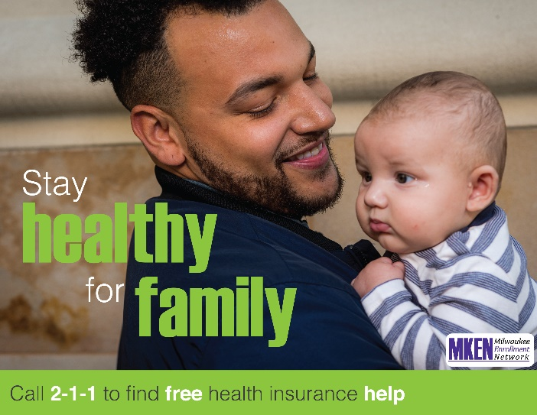
Regular check-ups keep your family healthy. Every health insurance plan in the Marketplace offers essential health benefits: doctor visits, preventive care, hospitalization, prescriptions, and more. Call 2-1-1 or enter your zip code at coveringwi.org/enroll to make an appointment for free, expert help.

Week of November 10-16, 2019
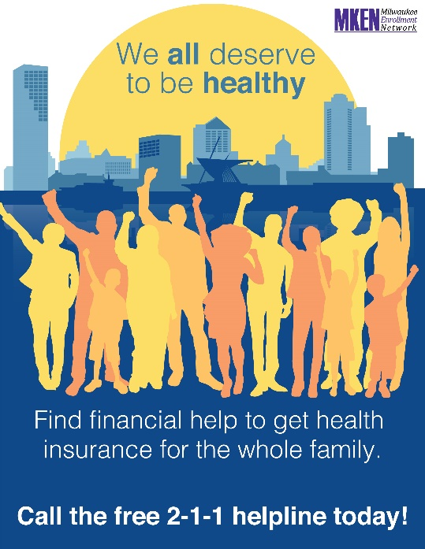
Need help to signing up for health insurance? Call 2-1-1 or enter your zip code at coveringwi.org/enroll to find FREE, local help.

Week of November 17-23, 2019
Look out for scams! Healthcare.gov is the official Health Insurance Marketplace. Call 2-1-1 or enter your zip code at coveringwi.org/enroll to work with an expert you can trust.

Week of November 24-30, 2019
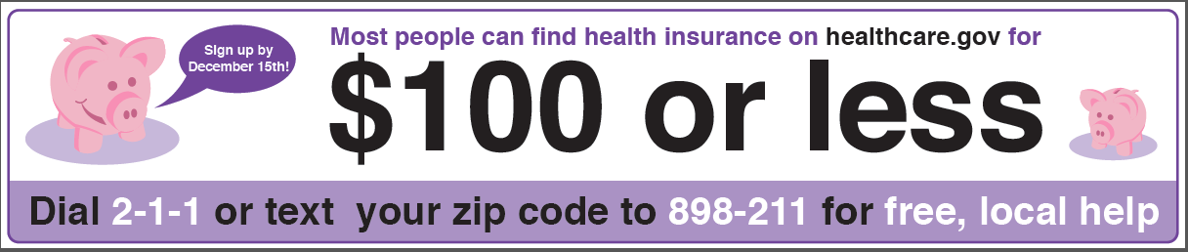
No one plans to get sick or hurt, but the truth is most people need medical care at some point. Find a plan that meets your health needs and fits your budget. FREE help! Call 2-1-1 or text your zip code to 898-211 to make an appointment.

Week of December 1-7, 2019
Do it for your kids! Call 2-1-1 or enter your zip code at coveringwi.org/enroll to set up a free appointment at a time that’s convenient for you. Schedule your appointment now - you only have until December 15th to sign up.

Week of December 8-14, 2019
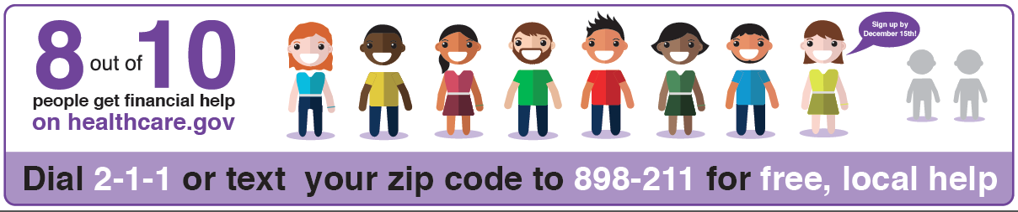
Open Enrollment is winding down! Sign up by December 15th. Get FREE LOCAL help today. Call 2-1-1 or text your zip code to 898-211 to make an appointment.

December 15, 2019
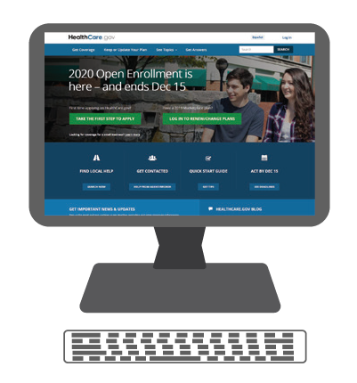
Today is the last day of Open Enrollment! There is a health insurance plan out there that fits your needs and your budget – let us help you find it. You have 3 ways to apply today:
- In-person help at Community Advocates between 9am-5pm (728 N. James Lovell St. Milwaukee, WI 53233)
- Online at Healthcare.gov
- Over the phone by calling 1-800-318-2596

