DOCTOR VISITS
Please post in newsletters, on your social media, in your facilities and at outreach events.

Poster / flyer


Bill board / social media ad
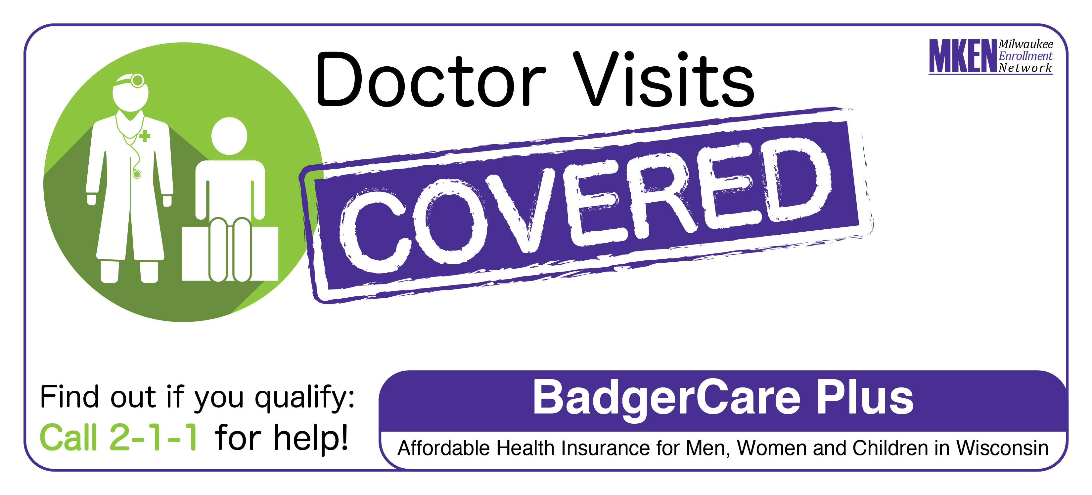
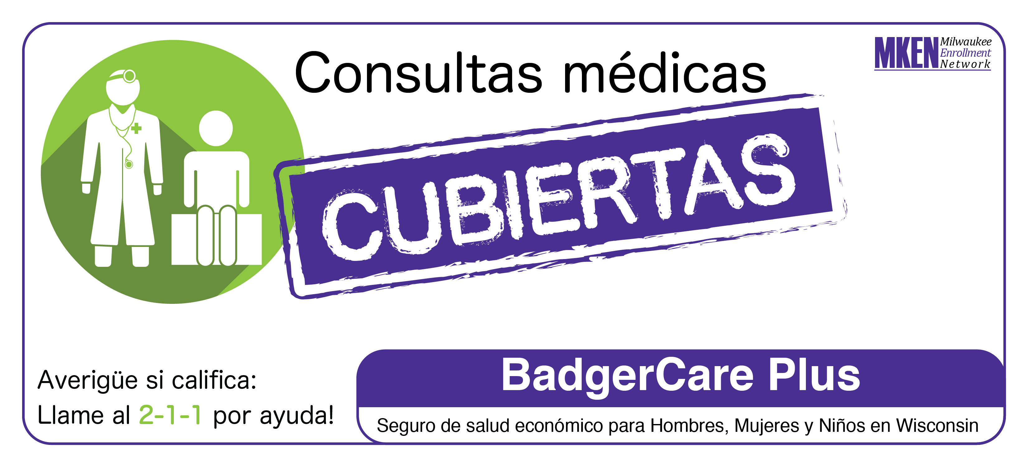

Bus ad (could be used in newsletters or other materials)

